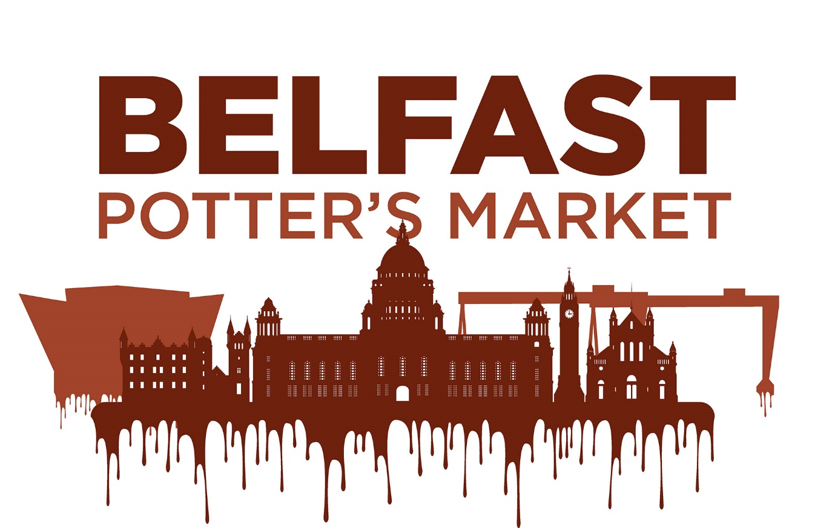

Introduction
The Christmas Belfast Potter’s Market is planned for Friday 1st and Saturday 2nd December for our first ever 2 day market. The market will take place at 2 Royal Avenue, where the old Tesco Metro used to be in Belfast. There will be up to 25 practicing potters and sculptors on the day, selling their locally handcrafted pottery and exhibiting their limited edition Christmas wares. The fabulously festive pottery market will have live demonstrations, free classes, festive music and hot drinks available from the café for visitors to enjoy as they browse the stunning handicrafts. Pottery makes a really excellent Christmas gift, that will get used and loved every day, so why not stop down, and pick up all your pressies in this real, one-stop-shop! On the day 2 Royal Avenue will also be hosting Santa’s Letterbox in a separate area, which should also drive a bit of extra footfall our way.
Timings: Set up is on Friday 1st, then the stands can be left up overnight and taken down again on Saturday after the market closes. Potter’s must commit to both days of the market.
Setup - Friday 2pm - 5pm
Trading Friday 5pm - 9pm , Saturday 10am-5pm
Break down Saturday 5pm – 6:30pm
Potters Meal + Drinks Saturday 6:30 - Late.
Unloading and Parking: You will be able to drive down royal avenue, heading from Craft NI towards mcdonalds, turn right just after the 2 royal avenue building, onto the pedestrian district and drive through the 1 way system up to the back of the building where we can unload. Ensure to drive no faster than 5mph and use your hazard lights when in the pedestrian area. Unload quickly then move your car again. You’ll then follow the loop around back onto Royal Avenue, take a left and head back up the way you came, take a left at the lights and you can then park in Handy Park which is at the back of Haymarket.
Toilets: Use of the toilet facilities in the 2 Royal Avenue
Entrance Fee’s: There will be no entrance fee for visitors.
Free Workshops: At summer we found the free workshops worked really well, they are a good selling point to attract visitors to the market! The plan is to have a sculpture station and a throwing station (1 Wheel) where visitors can have a go. I hope that each of you will volunteer atleast 1x hour to help facilitate these, it would strengthen your application however it is not essential. All materials / tools will be provided and you can have your business cards there to promote your own work / classes ofcourse while you are teaching.
Stalls:. Chairs and a limited number of 6FT tables are available, Stall holders will have up to 8Ft x 5FT of space in which to set up their stand. (This is space enough for a 6ft Folding table, a side display if you wish to use one and space to walk behind your stand.) The walkways are narrorw, so your stand cannot protude outwards into the walkway.
Lightining: The lighting has been upgraded in 2 Royal Avenue with lots of lovely spot lights, which are great if they happen to be pointing at your stand! Unfortunately these cannot be adjusted, so I would suggest that you bring some battery powered lights or an extension cable, and additional light for your stand, incase you arent getting any of the spotlights. (If you are using a lead you must tape it down well to prevent trip hazards.)
Applications & Fee’s
Applications will be open from 21st August – 4th September 2023 at 5pm, Applications made after this date will not be considered. Completed applications should be emailed to belfastpottersmarket@gmail.com .
The cost of a stall is £60 which must be paid within 1 week of your offer to confirm your spot, cancelled spaces will be refunded if we can find another potter to step in.
Insurance: Potter’s Attending must have Public Liability insurance to the value of £5 Million or more.
Products: The products you intend to sell at the event must all be of your own design and creation, no second hand products will be allowed unless they are part of a new piece.
Potter’s Meal / drinks: After the market I will be booking a restaurant for a potter’s meal and drinks for those who want them. An extra £25 deposit will be required with your stand fees if you wish to attend, this should cover a main course and a drink each and maybe a little bit of a kitty, but anyone ordering starters/deserts/ extra drinks should pay for these at the bar when ordering. For those who want to stay out late and party, make sure to park your car somewhere safe! Lets get a big turnout at the meal if possible, it’s a lovely way to round off the market.
Potter’s Potter: During the market each potter will be given an anoymous slip to vote for their favourite potter’s stand, you can vote for anyone other than yourself or Mud Ireland, the winner will receive a £100 sponsored prize from Scarva.

Application Details

Name: Fill Here
Email: Fill Here
Phone Number: Fill Here
Address: Fill Here
Buisiness Name: Fill Here
Social Media Handles: Use the proper @Handles for each if you want to be tagged on socials
Social Media Following: Fill Here
Description of Your Work (100 Words): Write in 3rd Person for to be used on social media.
What other Markets have you attended?: Fill Here
Would you like to attend the Potter’s Meal / Drinks? (£25 per person) : Yes/No if yes, how many people would you like to include?
Will you commit to teaching / demonstrating for atleast 1 Hour : Yes/No If yes, can you do sculpture, throwing or either?
Essential Requirements Potter’s attending must commit to / provide these with their application
- Public Liability Insureance (£5 million)
- 6x High Quality Images of your Work
- Commitment to sharing and promoting the event online
- Personally Invite at least 25 prospective customers to like the page and to the Social Media Event
- Potter’s must commit to both days of the market.

Please Email Completed applications, photos and proof of insurance to belfastpottersmarket@gmail.com

